i

.NET Core Azure

Sprint

**Online Retail Management System**

**Document Revision History**

|  |  |  |  |
| --- | --- | --- | --- |
| **Date** | **Revision No.** | **Author** | **Summary of Changes** |
| 29-11-2023 | 1.0 | Samatha Ramakrishna | Case Study Created |
|  |  |  |  |

**Table of Contents**

**Introduction 4**

Setup Checklist 4

Instructions 4

**Problem Statement 5**

Objective 5

Project Structure 7

Implementation 9

Summary of functionality to be built 9

**INTRODUCTION**

This document outlines a project for the .NET Line of Technology (LOT). The project is to develop Online Retail Management System. This document contains the requirements, workflow of the system and gives guidelines on how to build the functionality gradually in each of the course modules of the .NET LOT.

**SETUP CHECKLIST**

# Minimum System Requirements

* Intel Pentium 4 and above Windows 7
* Memory 8 GB
* Edge / Chrome browser
* SQL Server 2019 and SQL Server Management Studio
* Visual Studio 2022
* Visual Studio Code
* Git

**INSTRUCTIONS**

* The code modules in the Sprint should follow all the coding standards.
* Create a directory by your name in drive <drive>. In this directory, create a subdirectory Sprint. Store your Project here.
* High Level Design document should be created (HLD).
* You can refer to your course material.
* You may also look up the help provided in the MSDN
* Since this project work will span over week, you will need to take care of maintaining the code.

**Problem Statement**

The absence of an app presents several challenges for both consumers and retailers. For consumers, the lack of a dedicated app means they miss out on the convenience of easy browsing, personalized recommendations, and streamlined transactions. Without real-time updates and notifications, users may find it challenging to stay informed about promotions, new arrivals, or order statuses. On the retailer side, the absence of an online shopping app limits their reach to a growing market of mobile users, potentially resulting in lower sales and reduced customer engagement. Overall, not having an app can hinder both customer satisfaction and the competitiveness of retailers in the digital marketplace.

**Objective**

Development of Online Retail Management System to automate the online shopping for customer. The application is mainly used by customer and administrator.

# Abstract of the project:

The Online Retail Management system lets the customers register and shop by searching the product based on category, brand, etc. In order to buy the product the customer should login to the system, search the product, add to cart and make the payment. On successful payment, customer receives the confirmation message of product.

1. Administrator

* Manage Category
* Add, View and Delete category.
* Manage Sub Category
* Add, View and Delete sub category.
* Manage Product
* Add, View and Delete product.
* Remove a registered user.

1. Customer

* Search a Product
* Add product to shopping cart
* Make payment
* Provide comments for a product.

**MODULE LIST AND MODULE DETAILS**

# Modules

* Customer
* Admin
* Product
* Login

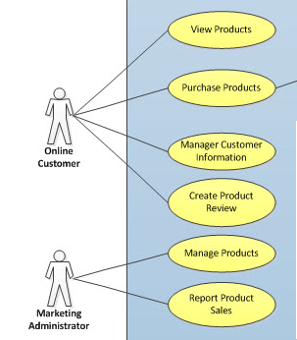

**PROJECT STRUCTURE**

The project should have minimum target framework – .NET 6.0 for Core WEB API Services and Angular 10 for UI Design

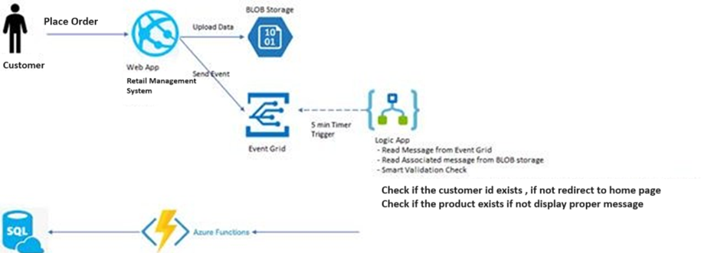

**API EXPECTATION**

Create API using

* + Visual Studio 2022 IDE
  + .NET 6.0 / C# 5.
  + Angular
  + SQL Server 2019
  + Entity Framework Core

**REQUIREMENT**

In this sprint, you must use:

* Angular
* Use Entity Framework Core
* Create Web API and host separately
* Functionality will be like services logic
* Web App
* Azure BLOB Storage
* Azure Function
* Azure Logic App

Create Client Application in Angular and Services using Web API Core and host them on Azure Cloud.

# Design guidelines

* All the exceptions/errors to be captured and user-friendly message to be displayed on the Common Error page.
* .NET Web API must be created using Code First Approach.

# Implementation

**SUMMARY OF THE FUNCTIONALITY TO BE BUILT:**

The participants need to develop Online Retail Management System by building the functionality incrementally in each of the course modules of .NET LOT.

|  |  |  |  |
| --- | --- | --- | --- |
| **Sr. No** | **Course** | **Duration** | **Functionality to be built** |
| **(in PDs)** |
| 1 | Angular  ASP.NET Core Web API  Entity Framework Core SQL Server  Azure services | 5 | Developing Angular App and Web API and hosting them on Web App (Azure App Service)  Using Azure BLOB Storage, Using Logic App to validate data,  Using Function app to write data to SQL  Server |